**Interactive data visualization project**

Topic: Environmental impact of digital technology

1st part: data exploration

**Minmin**:

1. Data introduction (background, variables, mission)
2. Comparing the weight of e-waste and carbon footprint

Purposes: Observe whether there is a correlation between weight and carbon footprint (positive correlation).

1. E-waste status vs. disposal methods

Purposes: Observe what recycling method is used for devices in different conditions.

**Sirine:**

1. Category distribution of electronic waste

Purposes: The distribution of e-waste by Category and which category has the most e-waste.

1. The export direction of electronic waste

Purposes: Analyze the export of e-waste in different countries and observe whether there are major exporting countries, for example, mainly to developing countries.

1. Comparing years of e-waste purchase with quantity

Purposes: The amount of e-waste recycled in different ways was observed and identified if there is a particular year with the most recycled devices.

**Tianjin:**

1. Basic information

Purposes: Understand the basics of data, including data types, missing values, and unique value statistics.

1. E-waste recycling price distribution

Purposes: Understand the distribution of the recycle price and observe whether the recycling price is concentrated in the low price (e.g., under $50) or whether there are more expensive recycling items (e.g., over $500).

1. Toxic component correlation

Purposes: The distribution of different toxic components is analyzed, and the toxic components that account for a higher proportion.

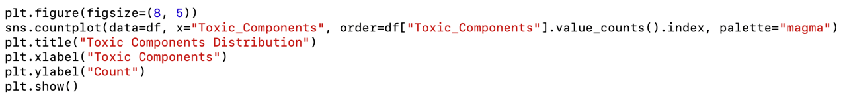

**Reminder:**

1. Our deadline is 19:00 tomorrow, and then we will discuss and modify our work on WhatsApp.
2. Write down the name and purpose of each statistic, then make a short conclusion of your analysis.
3. The code I give to you is just an example; don’t just copy and paste it.
4. If there is something you don’t understand, please tell me.